### Miniature House Pattern #2 - A Cape Cod

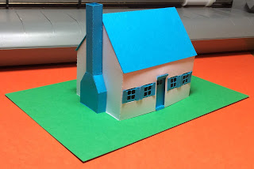

My second house in the series of miniature houses is a Cape Cod style house. The chimney is a free-standing chimney. The windows and doors do not have to be glued. There are tabs which are inserted into the window opening. The door has perforations that are folded around the opening on the top and bottom of the door.

